HBL Power Systems Ltd, India | Technical Description for  relay interface box for E-70

TECHNICAL DESCRIPTION FOR
RELAY INTERFACE BOX
for E-70

Document Number: 5 16 27 0036
Version: 1.1

Date Published: 23/06/2022

Prepared By
HBL Power Systems Limited
Hyderabad

This document and its content are the property of HBL Power Systems Ltd, who alone reserves the right for distribution use and reproduction

DOCUMENT DATA SHEET

Title of Document | File Name | Pages | Figures | Tables
Technical Description for Relay Interface Box for E-70 | Technical Description for Relay Interface Box for E-70 | 21 | 2 | -

Prepared by | Reviewed by | Approved by
D Lovaraju  (Engineer) | JVV Prasad  (Dy. Manager) | Y. Subrahmanyam  (Head -Engineering)

Abstract
This document describes the features and functions of the Reay Interface Box for E-70 and explains the design of the same.

DOCUMENT CONTROL SHEET

# | Name | Organization | Function | Level
1 | D Lova Raju | HBL | Engineering | Prepare
2 | JVV Prasad | HBL | Engineering | Verify
3 | Y. Subrahmanyam | HBL | Engineering | Approve

CHANGE HISTORY

# | Date | Reason for changes | Updated by | Version
1 | 25-05-2022 | Initial | D Lovaraju | 1.0
2 | 23-06-2022 | Updated | D Lovaraju | 1.1
GLOSSARY OF TERMS
# | Abbreviation | Meaning
 | A9 | Driver’s automatic brake lever for formation braking.
 | BC | Brake Cylinder
 | BP | Brake Pipe
 | CAN | Controller area network
 | DMI | Driver Machine Interface
 | EB | Emergency Brake
 | FR | Functional Requirement
 | FSB | Full-Service Brake
 | FTRTIL | Faiveley Transport Rail Technologies India Ltd
 | IRAB | Indian Rail Air Brake
 | LE | Light Engine
 | LP-OCIP | Loco Pilot’s Operation-cum-indication panel
 | MR | Main Reservoir
 | NB | Normal Brake
 | QRV | Quick-Release Valve
 | RIB | Relay Interface Box
 | SA9 | Independent brake Controller for Light engine braking.
 | SR | Safety Requirement
 | TCAS | Train Collision Avoidance System
 | BIU | brake interface unit
 | ATP | Automatic Train Protection
 | TCR | Traction Cut-off Relay

Table of Contents
1.0 SCOPE 8
2.0 PURPOSE 8
3.0 E-70 RIB FUNCTIONAL & SAFETY REQUIREMENTS 8
4.0 BRAKE APPLICATION ON LOCOMOTIVES 11
5.0 E-70 RIB DESIGN DESCRIPTION 12
6.0 E-70 RIB – Electrical Circuit 15
7.0 Electronics in E-70 RIB 16
7.1 Brake interface card (BIC). 17
7.2 BIC power supply card 17
8.0 COMPLIANCE WITH SAFETY REQUIREMENTS 17
8.1 Fail Safety 17
8.2 Health Monitoring 17
8.3 Isolation 18
9.0 Dimensional details of E-70 RIB 19
9.1 Without mounting arrangement 19
10.0 Technical Specification Sheets 19
11.0 Schematic diagram of TCAS RIB interface with an E-70 braking system 20
12.0 Block Diagram of Relay Interface Box for E-70 Locomotive. 21
Figure 2 : Block Diagram of Relay Interface Box for E-70 Locomotive. 21

- SCOPE
  - This document relates to the design of E-70 Relay Interface Box (E-70 RIB), for use on locomotives (WAP7/WAP5/WAG9) fitted with E-70 braking system of M/s FTRTIL.

- PURPOSE
  - KAVACH is designed to ensure safe train operation in the event of human failure by stopping or controlling the speed of trains.
  - For the sake of brevity, KAVACH will hereafter be referred to as ATP system
  - It is necessary for Automatic Train Protection (ATP) systems to be interfaced with the braking system of the locomotive for parallel braking application.
  - Under certain circumstances, it is also necessary to isolate the ATP braking and allow the Loco Pilot to operate the locomotive manually.
  - The purpose of this document is to propose the design of E-70 RIB for ATPs that fulfills the above safety requirements.

- E-70 RIB FUNCTIONAL & SAFETY REQUIREMENTS
  - The functional requirements of E-70 RIB are listed below.
# | Requirements
FR-1 | E-70 RIB shall work in parallel to the existing locomotive braking system (controlled by the Loco Pilot). The E-70 RIB shall pass the brake command signals to IRU (Interface Relay Unit of M/s FTRTIL) unit which has been interfaced with loco E-70 brake system.
FR-2 | E-70 RIB shall not modify the existing braking characteristics of the locomotive as well as other self-propelled vehicles treated as trains.
FR-3 | The E-70 RIB shall have provision for executing following brake commands  a) Normal Brake command  NB – BP Pressure Drop to 4.5±0.1 kg/cm2 from 5 kg/cm2  b) Full Service brake command  FSB – BP Pressure Drop to 3.5±0.1 kg/cm2 from 5 kg/cm2  c) Emergency brake command  EB – BP Pressure Drop to 0 kg/cm2 from 5 kg/cm2  d) Light engine brake command  Pressure build-up in Brake Cylinders to 3.5±0.1 kg/cm2
FR-4 | Based on the input signal from the ATP system through E-70 RIB, the existing brake control system shall apply the corresponding brake through IRU unit, as mentioned at FR-3 above.
FR-5 | Separate Relays shall be used for following brake applications  - Normal Brake  - Full-Service Brake  - Emergency brake  - Light Engine braking and  - QRV
FR-6 | On withdrawal of brake command from ATP system, the corresponding brake shall be released, and restoration of traction/throttle control shall be enabled.
FR-7 | There shall be a facility to override the "ATP system initiated braking" by the "driver’s braking" (or vice versa) to achieve higher braking intensity whenever required). Loco Pilot can override and increase braking effort generated by E-70 RIB, but not decrease the same. Also, the lower braking intensity of ATP shall be overridden by a higher braking intensity produced by other train safety systems, if any. Arrangement for data logging for the above scenario shall be available.
FR-8 | E-70 RIB shall be capable of receiving braking command simultaneously from the Loco pilot through Brake handle (A9/S9) as well as from the ATP at the same time. In case of multiple braking requests received simultaneously, the E-70 RIB should implement the command demanding for the highest braking effort.
FR-9 | E-70 RIB shall have provision to obtain feedback system about the execution of braking command given to it by ATP system and communicate it back to ATP system.
FR-10 | E-70 RIB shall have a provision of point-to-point communication with ATP system.
FR-11 | The communication between the E-70 RIB and the ATP system shall be on RS485. RS485 communication ports should have galvanic/optical isolation.
FR-12 | There shall be provision for Isolation of the complete E-70 RIB. Isolation shall be provided in case of malfunction. After isolation, the normal brake characteristics of the locomotive brake system shall not be affected.
FR-13 | The E-70 RIB shall have the facility to isolate itself from the loco pneumatic system through an isolation cock. The isolation shall be achieved through valve electrically operated by the E-70 RIB.
FR-14 | The Brake unit isolation shall be monitored, and its status shall be communicated by E-70 RIB to ATP system.
FR-15 | The E-70 RIB shall have a non-resettable counter to register the instances of brake unit getting isolated by the Loco Pilot.
FR-16 | The isolation switch shall be located on the E-70 RIB such that it is accessible for easy operation by the Loco Pilot.
FR-17 | There shall be a provision of manual isolation of the E-70 RIB. Pneumatic inlet pipe BP to E-70 RIB shall be provided with isolating cock to the unit.
FR-18 | E-70 RIB shall have a Self-Test feature for the detection of failed relays / sensors by performing self-diagnosis at power ON and give alerts to a user through ATP system display. The E-70 RIB shall have the facility to communicate its diagnostics information to ATP system.
FR-19 | E-70 RIB shall have provision for redundant control for emergency brake command, which shall be activated if the default control mechanism fails
FR-20 | For any internal failure in E-70 RIB, the following action shall be taken by E-70 RIB.  - Brakes will be applied.  - System goes to failure mode.
FR-21 | All supply voltages for operating the E-70 RIB shall be generated from loco battery which shall be in the range 78V to 136V DC.

  - Requirements for data logging of braking events generated by equipment connected to communication ports.
# | Requirement
FR-22 | Recording of E-70 RIB isolation event with date and time and number of counts of E-70 RIB isolation.
FR-23 | Arrangement for data logging for the braking event shall be available with ATP. The status of following events shall be logged at 1-sec interval/change in events, with date and time stamp  - ATP brake command active  - Isolation of E-70 RIB  - E-70 RIB failure log  - Relays failure log  - E-70 RIB Brake command override by Loco pilot brake command, vice versa  - Any change in BP/BC greater than 0.3Kg/cm² to be logged
FR-24 | The facility for the storage of data log shall be for 90 days. An application running on PC shall be provided for downloading the Log and evaluating the same.

  - The safety requirements of E-70 RIB are listed in the following table.
# | Requirements
SR-1 | The emergency brake command shall be fail-safe.
SR-2 | In case of power supply failure to E-70 RIB, the emergency brake shall get activated.
SR-3 | In case of communication failure between E-70 RIB and ATP system, the E-70 RIB shall command emergency brake.
SR-4 | In case of critical failure of E-70 RIB electronics interfaced with ATP system, emergency brakes shall get activated.
SR-5 | In the case of LE brake application by ATP system through E-70 RIB, BP pressure shall also be controlled (dropped) to ensure safe operation. This is to avoid mishaps that may arise due to the erroneous application of brakes to loco alone while working as a train formation.
SR-6 | In the case of manual isolation of E-70 RIB through the operation of cock, the isolation cock shall be provided with sensing input connected to E-70 RIB to detect the external pneumatic isolation. This information shall be communicated by E-70 RIB to ATP system.
SR-7 | There shall be a provision in E-70 RIB to cut-off traction in electric locomotive automatically whenever brake command signal is received on any of the inputs of E-70 RIB (through ATP system). Also, this shall be withdrawn as soon as brake commands are withdrawn.

- BRAKE APPLICATION ON LOCOMOTIVES
  - The brake system on a locomotive has two levers A9 and SA9, which the loco pilot uses to apply brake to train. In case the train is in formation, the brake lever A9 is used, while for a light engine SA9 is used.
  - The A9 Brake lever is a compact self-lapping, pressure maintaining brake valve which is capable of gradual application or release of locomotive and train brakes. A9 Automatic Brake Valve has five positions: Release, Run, Minimum Reduction, Full Service and Emergency. In the Release position, it provides a brake pipe pressure of 5Kg/cm2. In other positions, the brake pipe pressure is reduced to varying levels according to the required level of braking.
  - The required Brake Cylinder pressure corresponding to Brake Pipe pressure reduction in reverse proportion.
  - SA9 Independent Brake Valve is a compact self-lapping, pressure maintaining Brake Valve which is capable of gradual application or release of Locomotive Air Brakes independent of Automatic Brake. The SA9 Independent Brake Valve is also capable of releasing an automatic brake application on the Locomotive without affecting the train brake application. The SA9 Brake Valve has three positions: Release, Operational and Range/Application.

- E-70 RIB DESIGN DESCRIPTION
  - In a locomotive, the Loco Pilot adjusts the position of A9 lever to obtain the desired level of braking based on situational awareness through sensory perception.
  - With automated or mechanized train systems, there should be an automated mechanism of controlling the brake pipe pressure to obtain the desired level of braking. The proposed E-70 RIB design facilitates this automated mechanism, which is described in the subsequent sections.
  - At the core of the E-70 RIB consists of one interface card with external power supply. The E-70 RIB unit mechanism is assembled with electrically operated relays for braking application based on the brake command signal from ATP system.
    - There is a separate relay (3-relays for CAB-A & 3-relays for CAB-B) for each brake application for both CAB-A and CAB-B side, namely NB relay for normal brake, FSB relay for Full-service brake and EB relay for emergency brake.
    - One LE relay is used to operate light engine brake applications.
    - There is an additional QRV relay to operate EP relay valve for emergency exhaust of Brake Pipe pressure.
  - The E-70 RIB has a wiring/cable interface with IRU unit to pass the brake command signals received from ATP system.

  - NORAML BRAKE(NB)
    - Normal Brake Application
      - By default, the NB relay in E-70 RIB is in de-energized position.
      - Whenever a normal brake command is received from ATP system, the NB relay get energized and it energizes the NB relay in IRU unit, then the NB brake shall be applied through E-70 Brake system.
    - Normal Brake Release
      - When NB brake release command received from ATP system, the NB relay in E-70 RIB get de-energized and also the NB relay in IRU unit get de-energized and it releases the brake through E-70 brake system.

  - FULL-SERVICE BRAKE(FSB)
    - Full-Service Brake Application
      - By default, the FSB relay in E-70 RIB is in a de-energized position.
      - Whenever a FSB brake command is received from ATP system, the FSB relay gets energized and it energizes the FSB relay in IRU unit, then the FSB brake shall be applied through E-70 Brake system.
    - Full-Service Brake Release
      - When the FSB brake release command received from ATP system, the FSB relay in E-70 RIB get de-energized and also the FSB relay in IRU unit get de-energized and it releases the brake through E-70 brake system.
  - EMERGENCY BRAKE(EB)
    - Emergency Brake Application
      - By default, the EB relay in E-70 RIB is in de-energized position and the QRV relay in energized position.
      - Whenever an EB brake command received from ATP system, the EB relay gets energized and it energizes the EB relay in IRU unit, then the EB brake shall be applied through E-70 Brake system.
      - Simultaneously, the QRV relay get de-energized, and it drops the supply to EP Relay valve. The BP pressure will exhaust through the exhaust port of EP relay valve.
    - Emergency Brake Release
      - When EB brake release command received from ATP system, the EB relay in E-70 RIB get de-energized and also the EB relay in IRU unit get de-energized and it releases the brake through E-70 brake system.
      - Simultaneously, the QRV relay gets energized, and the EP relay valve and BP pressure will be blocked.
  - LIGHT ENGINE(LE) BRAKING
    - For the ATP system equipped loco, this awareness is available through a configuration on the LP-OCIP (DMI), which requires the loco pilot to select whether the loco is pulling a formation or operating as a light engine.
    - When LE mode is selected by the Loco Pilot on the DMI, ATP uses the Light Engine brake for adequate braking.
    - There is one additional relay for LE mode of operation, which enables the Light Engine unit (Fitted in E-70 brake panel) for LE brake application.

    - Normal Brake Application (LE mode)
      - By default, the NB relay and LE relay in E-70 RIB is in de-energized position.
      - Whenever a normal brake command is received from ATP system, the NB relay gets energized and it energizes the NB relay in IRU unit, then the NB brake will be applied through E-70 Brake system.
      - Simultaneously, the LE relay gets energized, and it enables the coil voltage of LE unit and applies brake through E-70 bake system.

    - Normal Brake Release
      - When NB brake release command received from ATP system, the NB relay in E-70 RIB get de-energized and also the NB relay in IRU unit get de-energized and it releases the brake through E-70 brake system.
      - Simultaneously, the LE relay gets de-energized, and it disables the supply to LE unit and brake will be released.

    - Emergency Brake Application (LE mode)
      - By default, the EB relay in E-70 RIB is in de-energized position and the QRV relay in energized position.
      - Whenever an EB brake command is received from ATP system, the EB relay gets energized and it energizes the EB relay in IRU unit, then the EB brake shall be applied through E-70 Brake system.
      - Simultaneously, the QRV relay gets de-energized, and it drops the supply to EP relay valve. The BP pressure will exhaust through the exhaust port of EP relay valve.
      - At the same time the LE relay also gets energized and applies the LE brake through E-70 brake system.

    - Emergency Brake Release (LE mode)
      - When EB brake release command received from ATP system, the EB relay in E-70 RIB get de-energized and also the EB relay in IRU unit get de-energized and it releases the brake through E-70 brake system.
      - Simultaneously, the QRV relay get energized, and which energizes the EP relay valve and BP pressure will be blocked.
      - At the same time LE relay also gets de-energized and releases the LE brakes through E-70 brake system.

  - TRACTION CUTOFF
    - TRACTION CUTOFF APPLICATION
      - In normal condition, Traction cutoff relay shall be in de-energized position.
      - Whenever there is a brake command (Service or Emergency) from ATP, the traction cutoff relay will be energized, and “NC” contact of the relay becomes “NO” and traction power will cut-off.

    - TRACTION CUTOFF RELEASE
      - After brake command is released by ATP, traction cutoff relay becomes de-energized and “NO” contact of the relay becomes “NC”. Traction power will be allowed.

    - TRACTION CUTOFF RELAY PLACEMENT
      - This relay is fixed in the CAB INPUT Box and designated inputs will be taken from the Loco SB panel.
      - These inputs will be connected to “NC” contacts of Traction cut-off relay.
      - These inputs may vary based on the Loco type.

- E-70 RIB – Electrical Circuit
  - The E-70 RIB electrical circuit consists of a micro-controller based electronic Brake interface card, an Isolation Switch and Relays.
  - Pressure sensors (MR, BP, BC1 & BC2) in critical areas of the braking system provide feedback to the BIC card for health monitoring and reporting.
  - The Brake interface card is connected to the ATP systems through RS-485 communication interface.
  - The status of the two inputs from the isolation switch (Service and Isolation) is monitored by the BIC.
  - For normal operation, the QRV relay should remain energized so that the brake pipe pressure is maintained. When E-70 RIB is isolated using the Isolation Switch, the QRV relay is still kept energized.
  - The following table shows the conditions of each relay under various braking applications. Here, the letter E indicates that the relay is energized, while D indicates that the relay is de-energized.

Position | NB  Relay | FSB  Relay | EB  Relay | LE  Relay | QRV  Relay | Traction cut-off  Relay
A9-Release | D | D | D | D | E | D
A9-NB Brake | E | D | D | D | E | E
A9-FSB Brake | D | E | D | D | E | E
A9-Emergency Brake | D | D | E | D | D | E
SA9-Release | D | D | D | D | E | D
SA9-Application | E | D | D | E | E | E
SA9-Emergency Brake | D | D | E | E | D | E
E-70 RIB isolation | D | D | D | D | E | D

- Electronics in E-70 RIB
The figure below shows the interface of electronic modules in E-70 RIB.
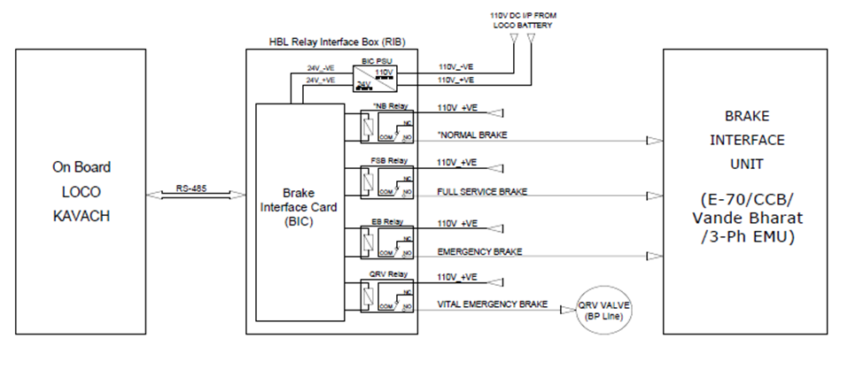

  - Brake interface card (BIC).
    - The brake interface card is the heart of the E-70 RIB system. This module is micro-controller based and performs the following functions.
    - The BIC card interfaces with ATP system on RS-485 communication link using optically isolated ports.
    - BIC controls the relays for commanding the formation and LE braking operations, as explained above in sections 5 and 6. The brake commands are received from ATP system.
    - For any brake application, the BIC card also generates an output by extending potential-free relay contacts. When the brake is released, these outputs will be withdrawn.
    - The air pressure in MR, BP and BC is sensed by BIC through pressure sensors.
    - BIC card Interfaces with an electro-mechanical counter for registering the number of times E-70 RIB is isolated.
    - BIC receives feedback from BP isolating cock when operated (Open / Close).

  - BIC power supply card
    - This is a power supply card that converts the loco battery supply 110V into 24volts output.
    - This power supply card is used for powering the relays.
- COMPLIANCE WITH SAFETY REQUIREMENTS
  - Fail Safety
    - If there is loss of electric power, E-70 RIB automatically applies emergency brake through QRV relay which operates EP relay valve.
    - If there is a loss of communication between ATP system and E-70 RIB, electronics in E-70 RIB will automatically cause to apply the emergency brake.
    - For any brake application, E-70 RIB activates a control signal that is used externally in the loco system for generating traction cut off.
  - Health Monitoring
    - E-70 RIB electronics circuit includes power supply health monitoring and appropriate corrective actions.
    - Heart-beat monitoring of relays:
      - Brake Interface Card in E-70 RIB monitors voltage and current of each energized relay, once every 200ms.
      - If the voltage and current values of any relay cross defined tolerance limits, the corresponding relay is flagged as unhealthy.
      - In such an event, TCAS displays a message on the DMI that E-70 RIB is unhealthy (<BRAKE Fault>) and will apply Emergency Brake.
      - The same event will be logged in ATP system.
  - Isolation
    - The E-70 RIB can be electrically isolated by the use of an Isolation Switch provided on the front panel of E-70 RIB.
    - Operation of the Isolation Switch also causes all the relays, except QRV, to de-energies thus isolating the brake signals completely. QRV is energized and emergency brake is released. Upon isolation, the original pneumatic circuit of the loco will function under control of the Loco Pilot.
    - E-70 RIB electronics will communicate to the ATP that the E-70 RIB had been isolated. This causes the ATPs to switch to an appropriate mode of operation, as indicated in their respective specifications.
    - The BP isolation cock is provided with sensing input connected to the E-70 RIB brake interface card to detect the pneumatic isolation and this information is communicated by E-70 RIB to respective ATPs to switch to the appropriate mode of operation, as indicated in their respective specifications.


TCAS will switch to Standby mode if either of the cock is closed.
In this condition, Loco TCAS does not provide train protection features.
- Dimensional details of E-70 RIB
  - Without mounting arrangement
The external dimensions of E-70 RIB are 479 (W) x 488 (H) x 192 (D) mm. The figure below shows the E-70 RIB without the mounting arrangement.
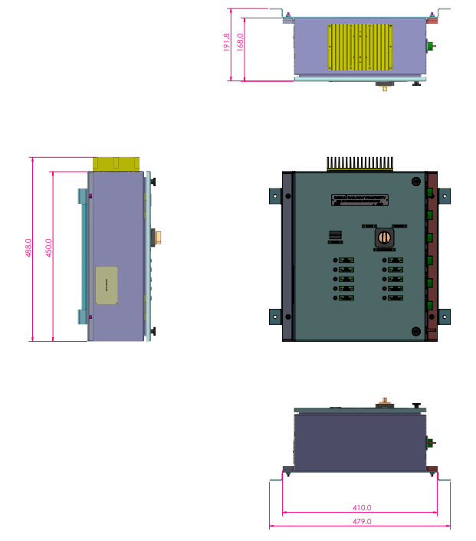

- Technical Specification Sheets
# | Item | Reference datasheet
1 | Relays | 
2 | Pressure Sensors | 

- Schematic diagram of TCAS RIB interface with an E-70 braking system

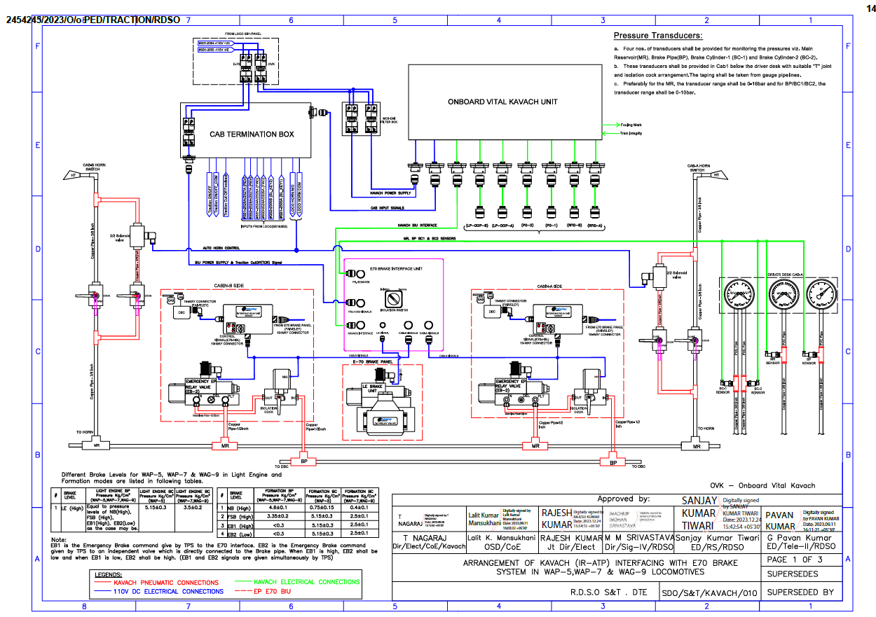
- Block Diagram of Relay Interface Box for E-70 Locomotive.
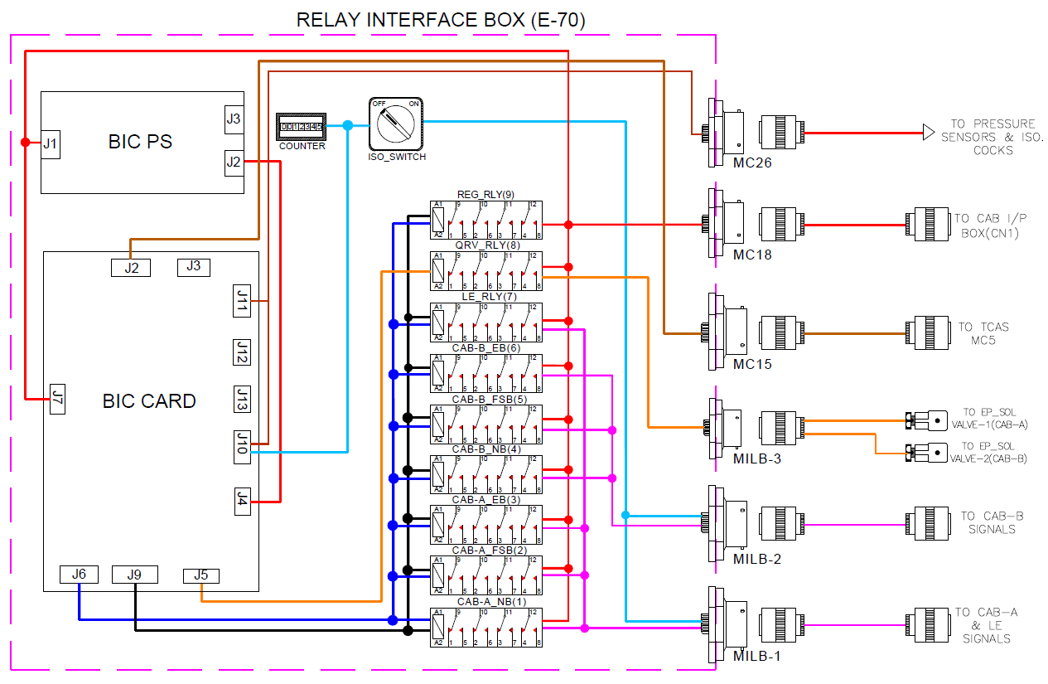

Figure 2 : Block Diagram of Relay Interface Box for E-70 Locomotive.

